Assignment 4: Colorization

# Group Members

* **Harshil Patel:** Improved Agent + Questions
* **Mehul Patel:** Preprocessing + Documentation + Helper Functions + Questions
* **Jonathan Pinto:** k-means **+** Basic Agent + Questions

# Notes about Project

# Questions and Writeup

## The Basic Agent

How good is the final result? How could you measure the quality of the final result? Is it numerically satisfying, if not visually?

* The final result for K-means was very good. K-means worked really well and found good representative colors within 10 iterations despite the number of centroids. If you look at graphs from 12 - 17 and the associated image, the colors look representative of the image itself.
* The final result for the other part of the basic agent was alright. In terms of finding the correct centroid, it did well. If you look at graphs 1 - 11, you can see the results of recoloring with and without using weights while using either 5, 10, 20, or 30 centroids. The accuracy and loss that you see is calculating if the basic agent picked the wrong centroid. So for example, if it picked a green centroid over a red centroid, the loss would be calculated as the distance from the green centroid to the red centroid. Note, this loss is not the Euclidean distance, but rather, the Manhattan distance. The accuracy was calculated by taking the subtracting the loss by 768 (768 because 256*3 pixels in total) and then dividing by 768 again. Therefore, that is why the accuracy is very high, since the difference between the centroids were often not too large on average.
* On the other hand, if you simply look at the accuracy between the real color value and the predicted color, the accuracy is quite bad. **This is the accuracy that was used when calculating the accuracy for the improved agent**. When looking at the normal accuracy, it is any where between 65% and 80%. As I increased the number of centroids, although it looked better, the accuracy was decreasing. Therefore, I concluded that this was not a good estimate to tell if the result looked “good”.

## Bonus

Instead of doing a 5-nearest neighbor based color selection, what is the best number of representative colors to pick for your data? How did you arrive at that number? Justify yourself and be thorough.

* The best number of neighbors is really depended on the picture. For the first picture, 10-15 centroids was fine. However, for the second image, 15-20 centroids fit better. Also, I justify these numbers by looking at the accuracy and the way it looks. As you can see in the graphs, graph 3 and 4 with 10 centroids have the best accuracy and it also looks pretty great. Also, for the second image, graph 11 with 20 centroids has the best accuracy and looks the best. Therefore, the best number of colors to pick heavily depends on the picture and how many unique colors the picture has and the range of the RGB values.

# The Improved Agent

1. Solution

The solution we used for the improved agent was a combination of the k-means clustering used in the basic agent and neural networks. The number of layers, nodes per layer (other than the input and output layers), and learning rate were not fixed, i.e. these values were passed into our function that created such a network. The input space was a linear array containing the 9 gray scale pixel values contained within a 3x3 cluster. The output space was an array of probabilities [p0, p1,..,p­i,.. , pn-1] where p­­i represents the probability that the center pixel of the cluster is closest to the centroid ci. Thus, the predicted color of the center pixel would be cm, where m represents the index of the maximum probability pm contained in the probability output array. We added an extra aspect to this, as well. To account for the case where probabilities are similar to each other (for example, when there are many centroids) we pick 2 or 3 centroids with maximum probabilities within 1% of each other, and take their average color to be the color of the center pixel. This did not always yield better results, however, as it may depend on the range of centroid colors as well; as such, to use this method or not was determined by a boolean parameter, useAvg. The layers of the networks utilized the sigmoid activation function with both weights and biases, however for the last layer we used the softmax activation function in order to give us a probability distribution (all output probabilities add up to 1). Since we are dealing with softmax and probability distributions, the loss function we chose was the cross entropy loss function:

L = -y­real*log(y)

However, since y_real was simply an array of zeroes other than the for the closest centroid at index m, this reduces to

L = -log(ym)

The algorithm learned by updating weights and biases based on forward propagation and back propagation on each of the size 9 gray scale arrays in the training data set.

2. How did you choose the parameters (structure, weights, any decisions that needed to be made) for your model?

The parameters for the model (number of layers, nodes per layer, learning rate, centroids, max iterations, useAvg) were mostly chosen via testing. We determined the number of centroids to use by testing the centroids used for basic agent. Generally, 10-25 centroids produced good results. We found that for learning rates > .1, our model suffered from overfitting and returned only a single color no matter the input. The optimal learning rates were between .005 and .04, for 4 layers and 270 nodes per layer. In most cases, 5-10 iterations over the image were sufficient for reasonable results; beyond this, there are no major improvements and the overfitting issue mentioned earlier may come up.

3. Any pre-processing of the input data or output data that you used.

There is a function in our code that returns the training and testing datasets given the image data and list of centroids as inputs. This is done by going through each 3x3 cluster in the left half of the image (this excludes border pixels), finding the closest centroids, and converting the pixels to gray scale. The returned training data is in the form of a 2D array, where each row is a list of gray scale pixel values from each 3x3 cluster. The returned testing data is also a 2D array where each row is a list of 0’s except for the list index corresponding to the index of the closest centroid for the center of the 3x3 cluster in the same training data row.

4. How did you handle training your model? How did you avoid overﬁtting?

To train the model, we iterated through the training cluster/output pairs. Prior to iteration, they were shuffled to avoid imaging bias and overfitting. We also avoided overfitting by keeping the network relatively “flat”, i.e. by using a small number of layers, as we found that adding more layers resulted in single color outputs as well. Lastly, we terminate the program once the accuracy decreases twice.

5. An evaluation of the quality of your model compared to the basic agent. How can you quantify and qualify the diﬀerences between their performance? How can you make sure that the comparison is ‘fair’?

We can compare the results quantitatively by comparing the average accuracy between the predicted image and the true RGB color of the image for both. For basic agent, the normal accuracy was generally between 65 and 80%. This was generally not the case for the advanced agent, which usually yielded results between 85 and 97%. To keep the comparison “fair”, we compare the results between the basic agent and advanced agent using the same number of centroids for each.

6. How might you improve your model with suﬃcient time, energy, and resources?

We could improve our model with extensive testing. Our model included many parameters, and it is possible that there are more optimal parameters than the ones we have used. We could have also incorporated more mechanisms to deal with overfitting, such as Ridge and Lasso regression. Our network was fully connected, and using this kind of regularization may add some more disconnect where necessary which could lead to improvements. Training over the image several times also was not efficient time wise, so there is room for improvement there as well.

# Figures

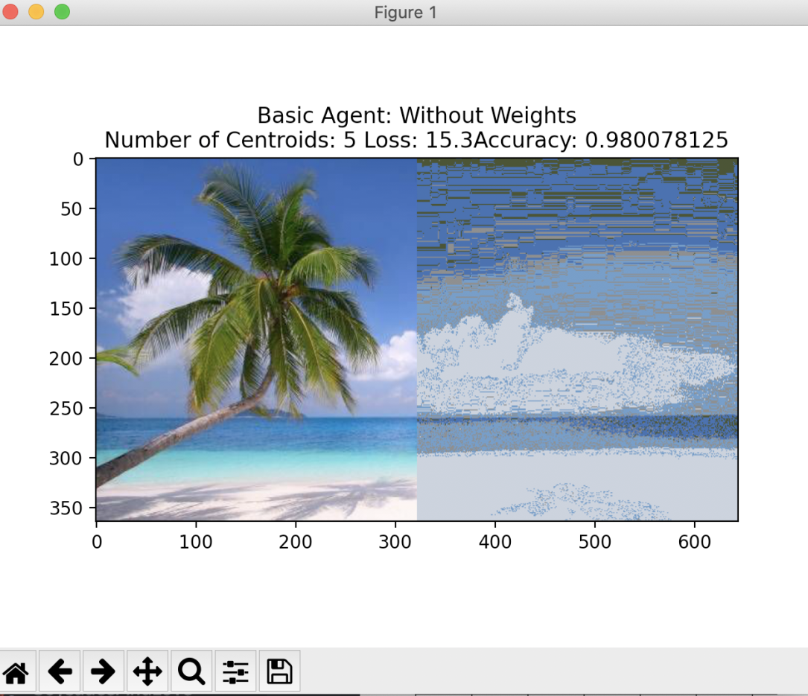

Graph 1 Basic Agent without weights with 5 centroids

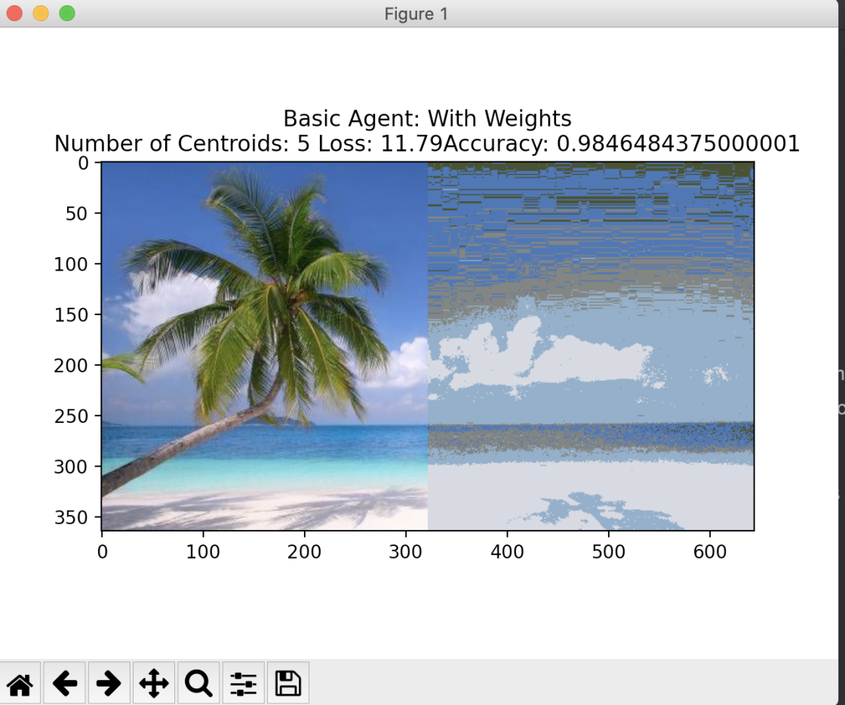

Graph 2 Basic Agent with weights with 5 centroids

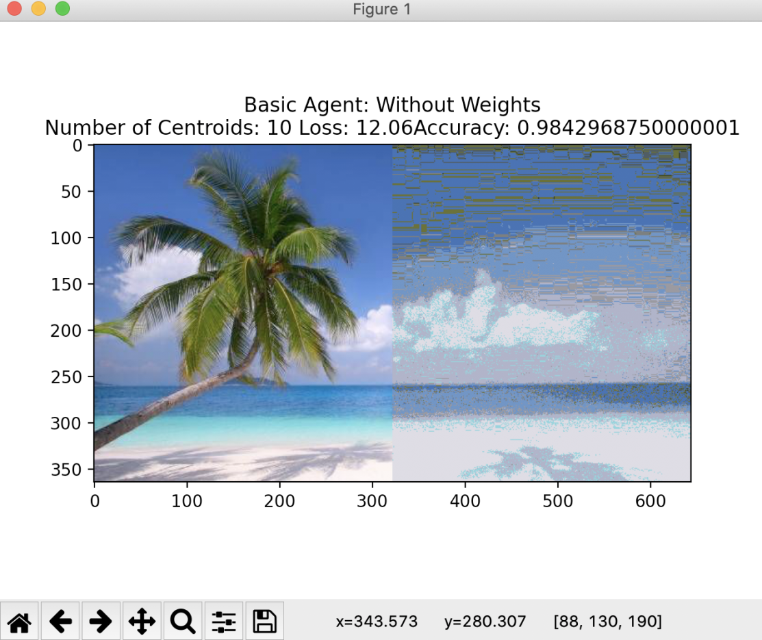

Graph 3 Basic Agent without weights with 10 centroids

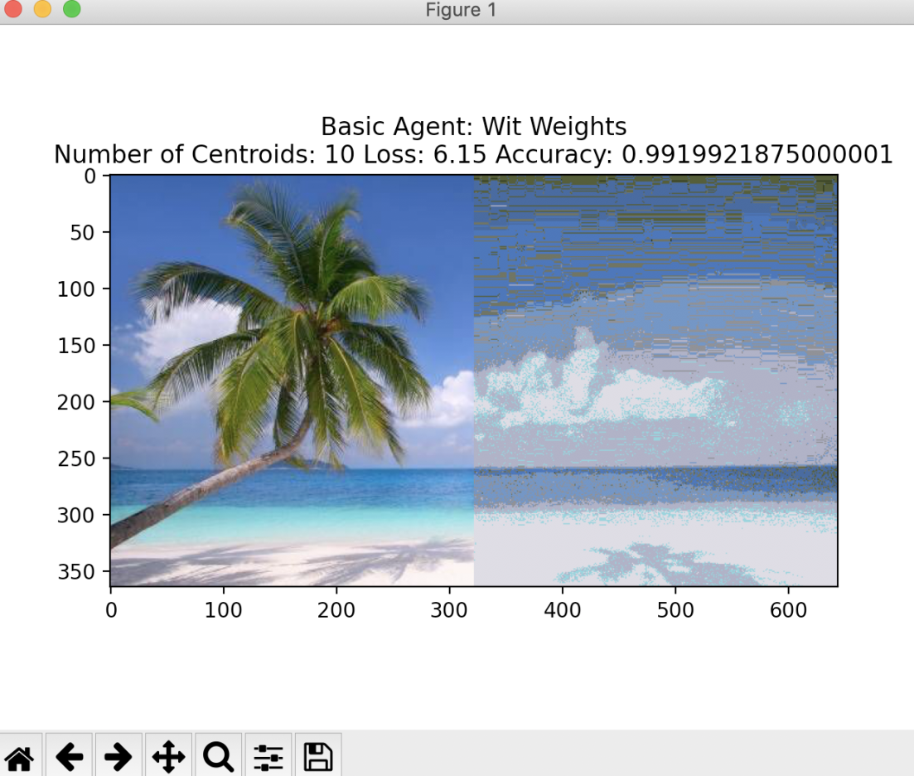

Graph 4 Basic Agent with weights with 10 centroids

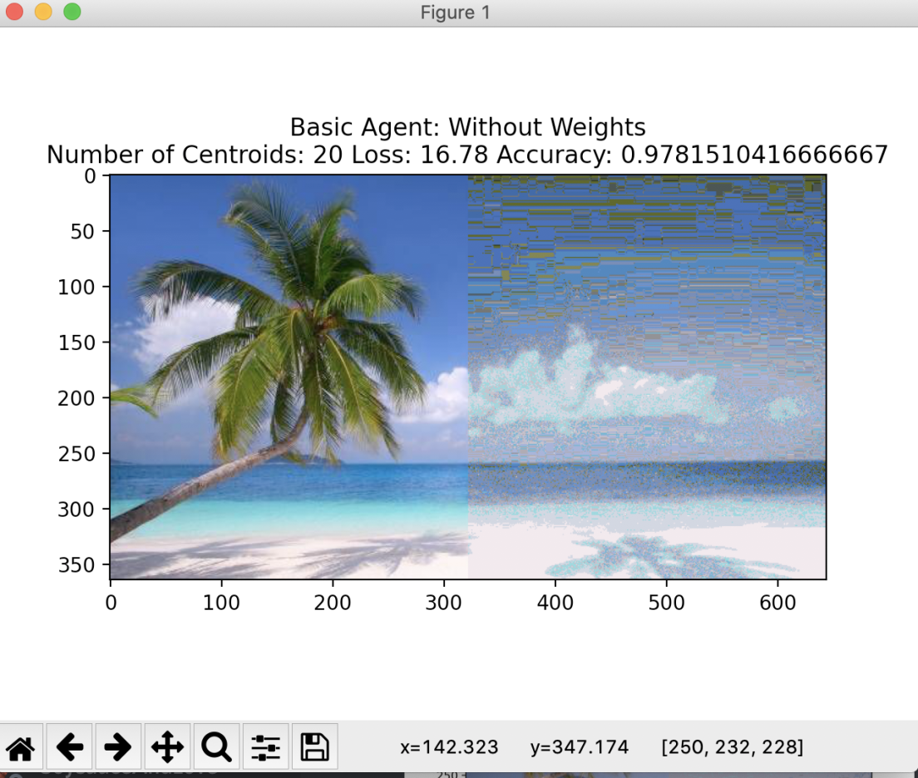

Graph 5 Basic Agent without weights with 20 centroids

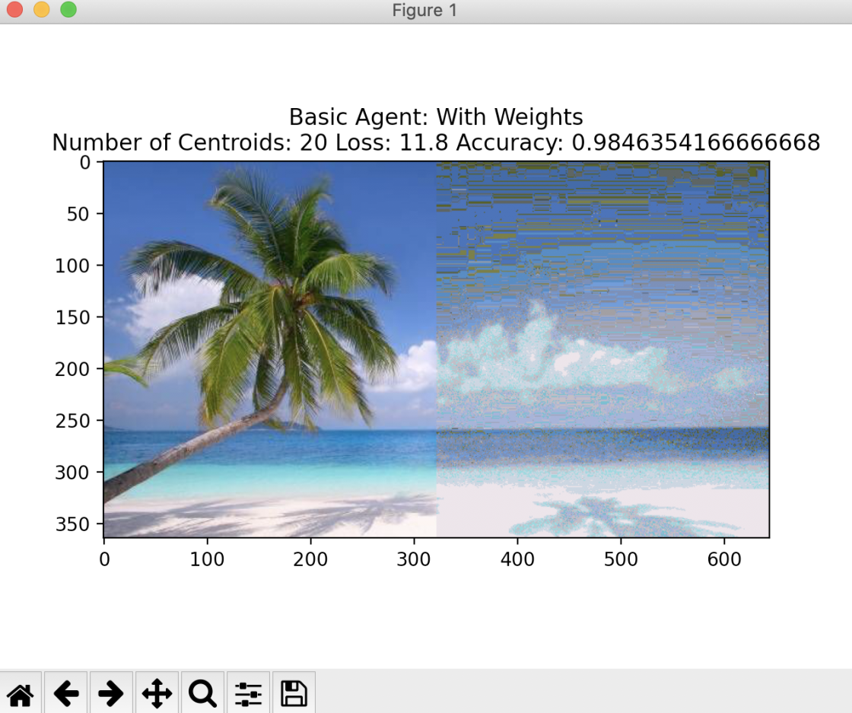

Graph 6 Basic Agent with weights with 20 centroids

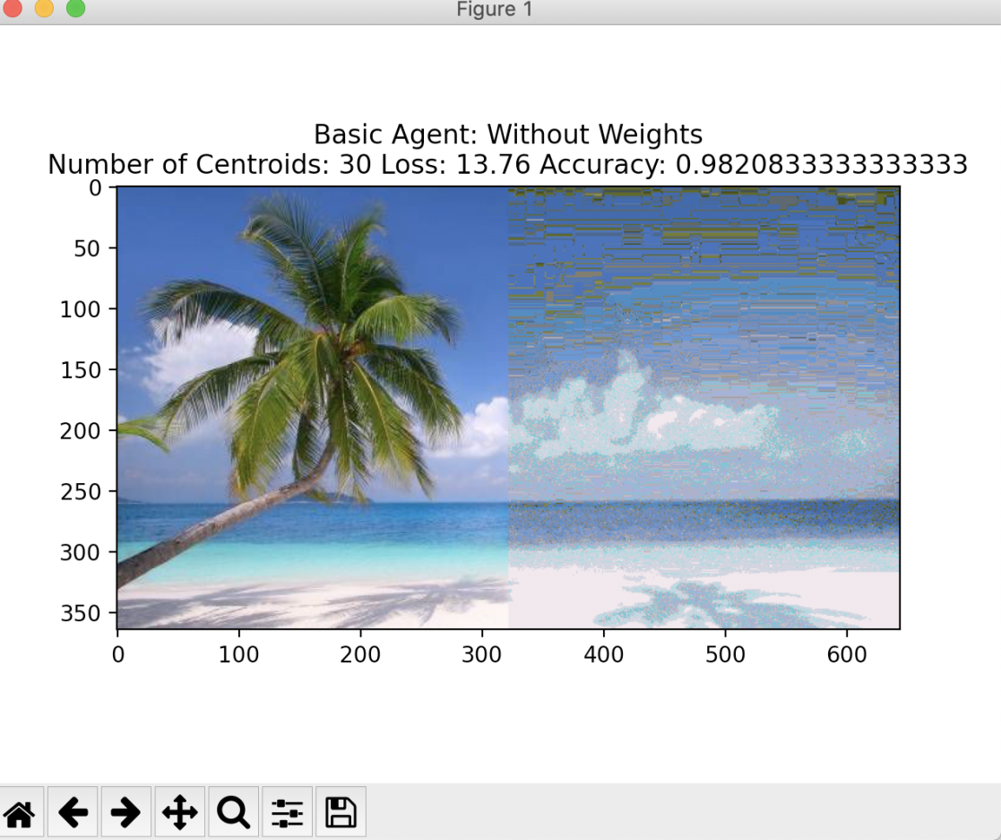

Graph 7 Basic Agent without weights with 30 centroids

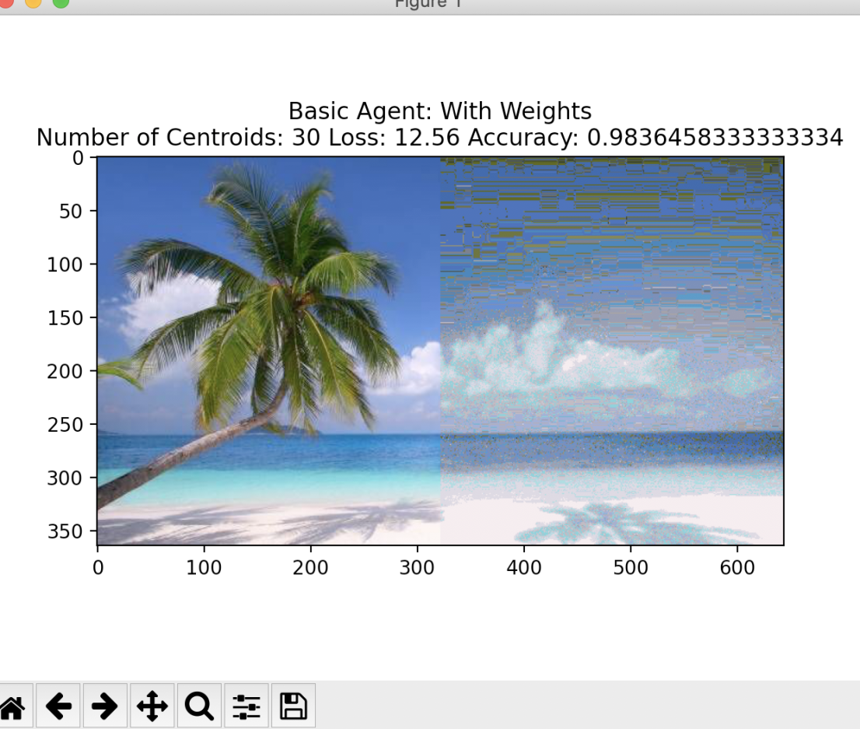

Graph 8 Basic Agent with weights with 30 centroids



Graph 9 Basic Agent with weights with 5 centroids: Image 2



Graph 10 Basic Agent with weights with 10 centroids: Image 2



Graph 11 Basic Agent with weights with 20 centroids: Image 2



Graph 12 K-means 5 centroids: Image 1



Graph 13 K-means 10 centroids: Image 1



Graph 14 K-means 20 centroids: Image 1



Graph 15 K-means 5 centroids: Image 2



Graph 16 K-means 10 Centroids: Image 2



Graph 17 K-means 20 Centroids: Image 2